
Year 9

Mini Test 1

Simple Interest, Area, Surface Area and Volume

Total Marks: 32 marks
Name: ______________________ Total Time: 40 minutes

Show working and answers on this sheet. Show working in sufficient detail to support your answers. Incorrect answers without supporting reasoning may be allocated zero marks.
Resources Allowed – 1 A4 Page (1 Side) of Notes, Calculator

Question 1 4 marks
- How much interest is earned on a Principal of $4000, invested at a rate of 6% per annum for a term of 5 years?
A $1495 B $1200
C $1500 D $1800

- A washing machine costs $700. If it is paid off over three years at 15% per annum simple interest, how much interest is paid?
A $105 B $315
C $420 D $805

Question 2 10 marks
Find the area of the following. Give answer to 1 decimal place.

[2 Marks]

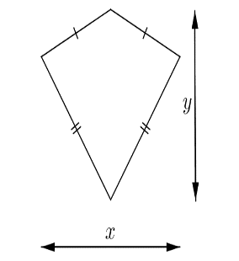

7 km
5 km

[2 Marks]

c.
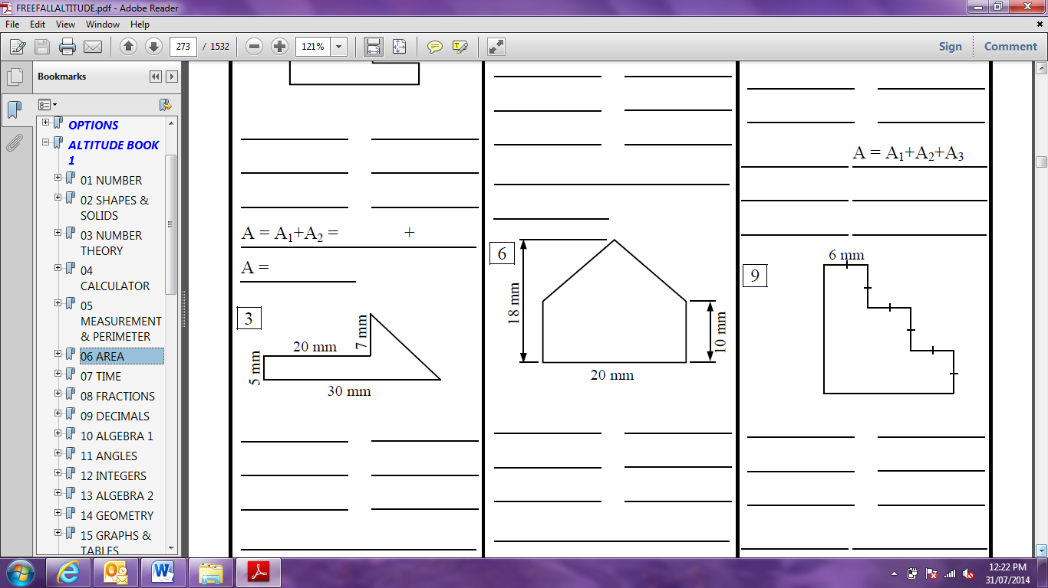

[3 Marks]

d.
10 cm
12 cm

[3 Marks]

Question 3 4 marks
Find the surface area of each of the following prisms:
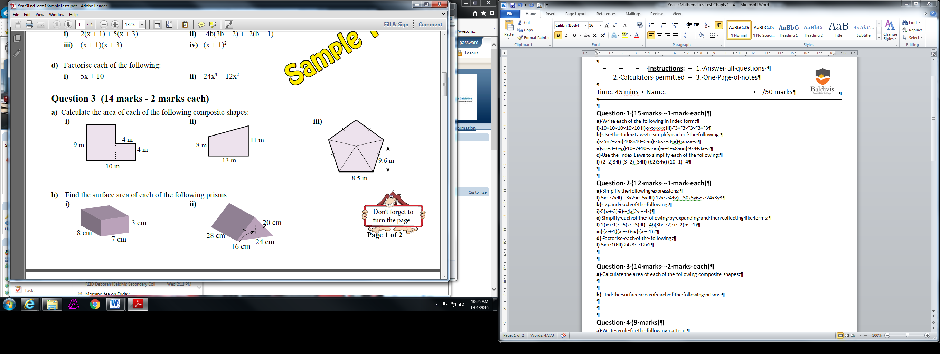
20 cm

Question 4 3 marks
This diagram represents a new storage building.
Find:
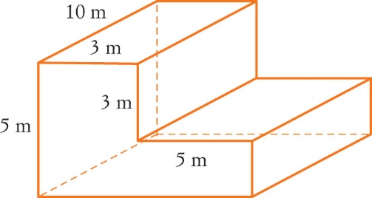
a the area of the front.

[2 marks]

b the volume of the building.

[1 mark]

Question 5 5 marks
- Mike took out a loan with an interest rate of 12.5% over 4 years. The interest he paid on the loan was $3250. Calculate the Principal amount he originally borrowed.

- Joe buys a car worth $24 000. He makes payments of $550 every month for five years. What rate of interest is he paying?

Question 6 6 marks
A room has ceilings 250 cm high and is 5 m by 370 cm. Ignoring doors and windows, find the surface area of the walls and the cost of painting the walls at $14.50/m² .

